- Simple Intransitive Sentence
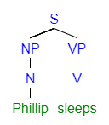
- Intransitive Sentence with Two Noun Phrases
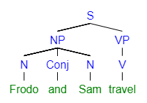
- Intransitive Sentence with Two Verb Phrases
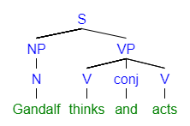

- Determiners
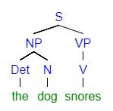

- Adjectives in a Noun Phrase
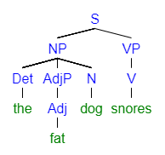
- Prepositional Phrase in a Noun Phrase
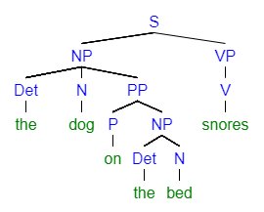
- Prepositional Phrase in a Verb Phrase
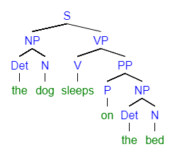

- Adverb in a Verb Phrase
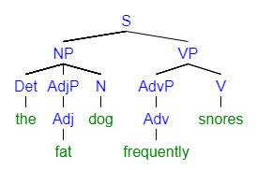
- Adverb in an Adjective Phrase
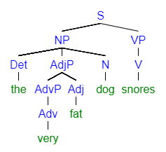
- Copular “Be” Sentence with a Prepositional Phrase as an Adverbial
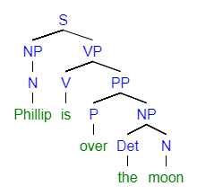

- Copular “Be” Sentence with an Adverb Phrase as an Adverbial
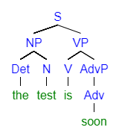
- Copular “Be” Sentence with a Noun Phrase as a Subject Complement
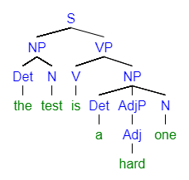
- Copular “Be” Sentence with an Adjective Phrase as Subject Complement
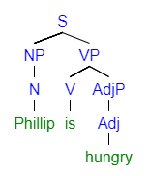

- Linking Verb with an Adjective Phrase as a Subject Complement
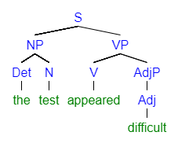
- Linking Verb with an Noun Phrase as a Subject Complement
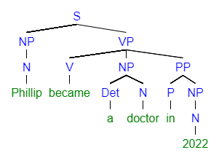

- Transitive Verb with a Direct Object
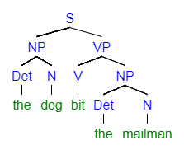

- Transitive (ditransitive) verb with a Direct Object (a bone) and an Indirect Object (the dog)
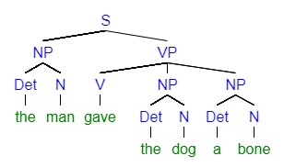

- Transitive (ditransitive) verb with a Direct Object (the test) and an Adjective Phrase as an Object Complement (difficult)
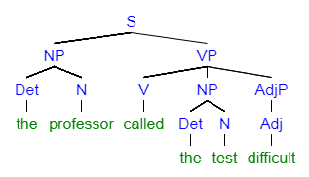
- Transitive (ditransitive) verb with a Direct Object (the test) and an Noun Phrase as an Object Complement (a beast)
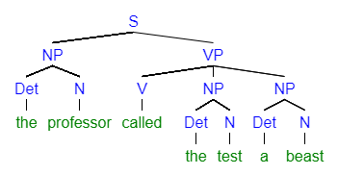

Unit Two
- Auxiliary Verbs
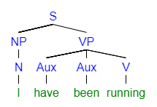

- Modals
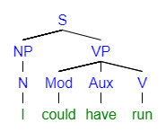
- Optional Main Verb Phrase Level
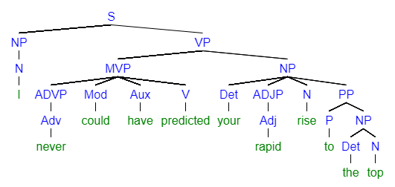

- Passive Voice
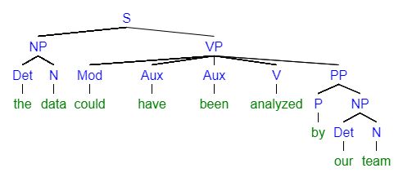

- Coordination (coordinating conjunction)
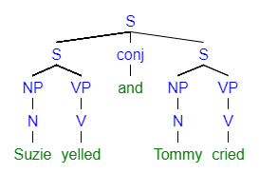
- Subordination (dependent clause second)
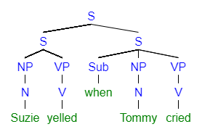
- Subordination (dependent clause first)
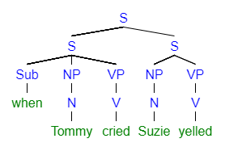

- Nouns as Adverbials
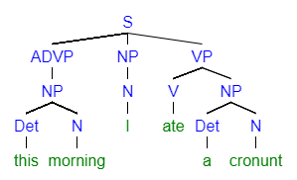

- Verbs as Adverbials (Present Participles)
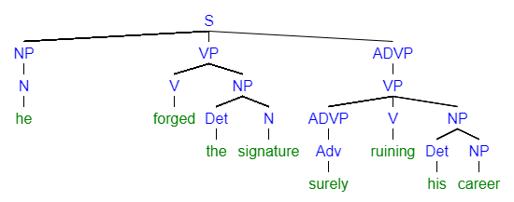
- Verbs as Adverbials (Infinitives)
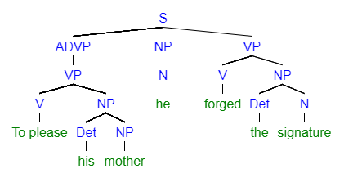

- Verbs as Adjectivals (Present Participle)
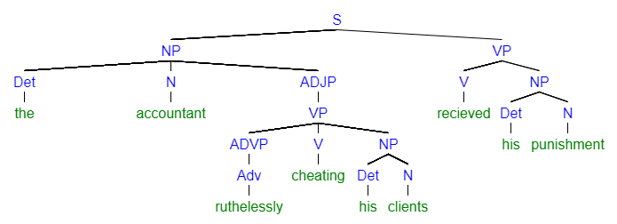
- Verbs as Adjectivals (Past Participle)
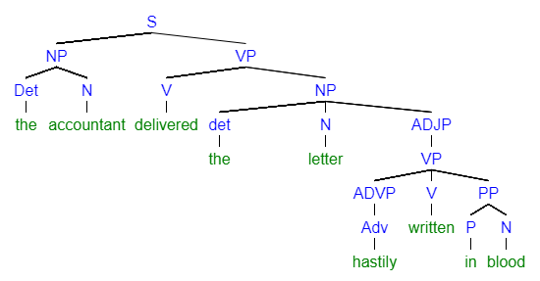
- Relative Clauses with Relative Pronouns [Relative Pronoun as Subject]
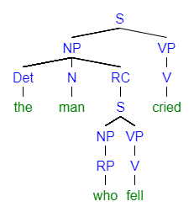
- Relative Clauses (Relative Pronoun as Relativizer – Relativizer as Subject of RC)
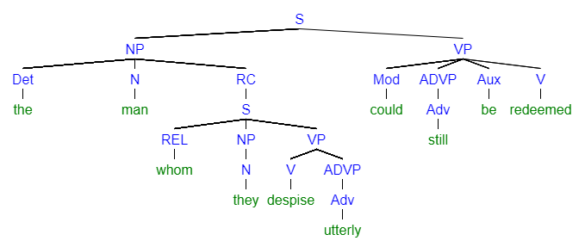
- Relative Clause modifying a Direct Object (Relative Adverb as Relativizer)

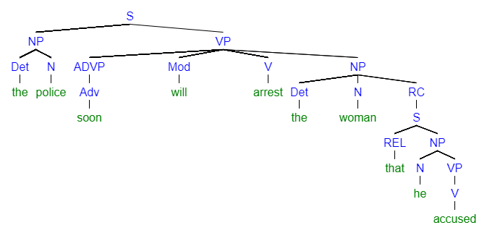

- Empty Relativizer – Relative Clause Modifying a Subject (Empty Relativizer)
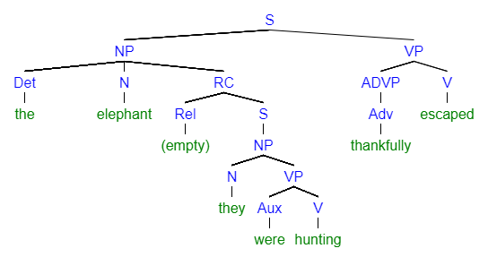
- Complement/Nominal Clause in Object Position (Complementizer as Subject)
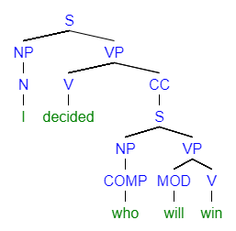

- Complement/Nominal Clause in Subject Position (Pronoun as Subject)
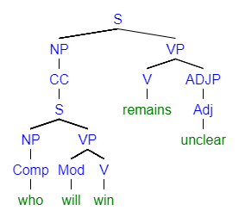

- Complement/Nominal Clause in Object Position (Complementizer)
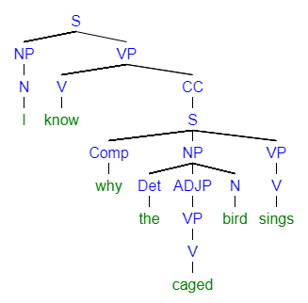

- Missing Complementizer: Complement/Nominal Clause in Object Position
